**HOW TO CREATE ORACLEDB USER ON COMMAND LINE**

**(StackOverflow Answer by Steve Ruben and Starball)**

In Oracle 12c and above, we have two types of databases:

1. Container DataBase (CDB), and
2. Pluggable DataBase (PDB).

If you want to create a user, you have two possibilities:

1. You can create a "container user" aka "common user".  
   Common users belong to CBDs as well as to current and future PDBs. It means they can perform operations in Container DBs or Pluggable DBs according to assigned privileges.

create user c##username identified by password;

1. You can create a "pluggable user" aka "local user".  
   Local users belong only to a single PDB. These users may be given administrative privileges, but only for that PDB inside which they exist. For that, you should connect to pluggable datable like that:

alter session set container = nameofyourpluggabledatabase;

and there, you can create user like usually:

create user username identified by password;

Don't forget to specify the tablespace(s) to use, it can be useful during import/export of your DBs. See this for more information about it <https://docs.oracle.com/database/121/SQLRF/statements_8003.htm#SQLRF01503>

**-------------------------------------------------------------------------------------------------------------------**

**(Tutorial from geeksforgeeks.org)**

As we create a new user in the Oracle database, we first need to grant it the required privileges. After that only we can use that user to perform any task, provided that task comes under the role of privileges provided to it. This is illustrated below. For this article, we will be using the SQL Command-Line.

*NB: If you are trying to create a user from a container database (CDB) you should put C## before the username in your command line.*

**Step 1:** Open the SQL Command Line by typing run in the Search toolbar and selecting the option of Run as administrator. The SQL Command Line opens.

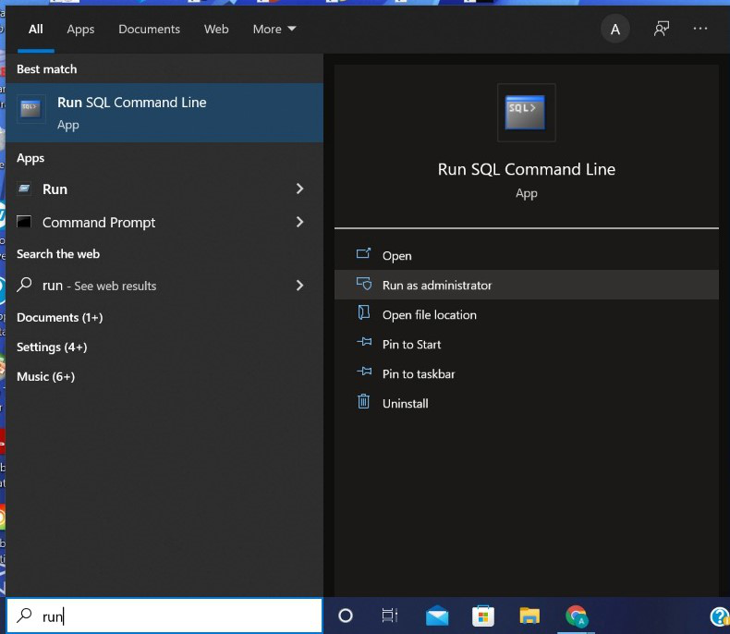

**Step 2:**The following screen appears after clicking “Yes” on the dialog box which appears after step 1.

**Output:**

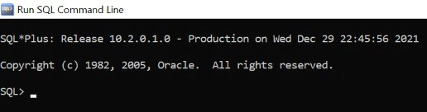

**Step 3:** Connect to the oracle database using CONNECT command.

**Query:**

CONNECT

Hit ENTER after typing the command.

**Output:**

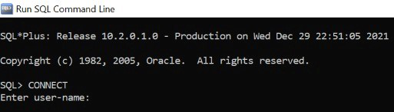

**Step 4:** Login using the default user i.e. the SYSTEM user. So type in the user-name as SYSTEM and then type in the correct password and hit Enter.

**Note:**The password for the SYSTEM user is set during Oracle installation.

**Output:**

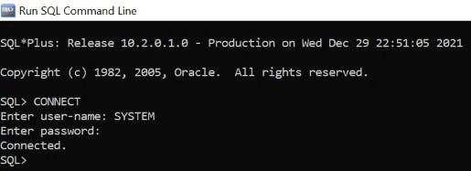

**Step 5:** Now, we create a new user named GFG.

**Syntax:**

CREATE USER NEW_USER_NAME INENTIFIED BY PASSWORD;

**Query:**

CREATE USER NEWUSERGFG INENTIFIED BY GFGQWERTY;

**Note:**Here, we set the password as GFGQWERTY.

**Output:**

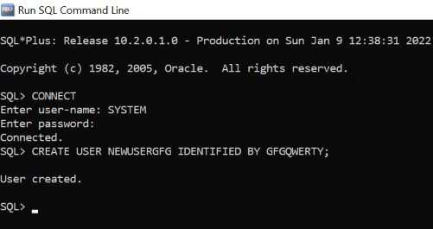

**Step 6:** Now, we close this session and reopen the SQL Command Line using Steps 1 and 2. We try to CONNECT to the session using NEWUSERGFG user-name. An error is thrown as the user NEWUSERGFG doesn’t have the privilege to start a session.

**Query:**

CONNECT

**Output:**

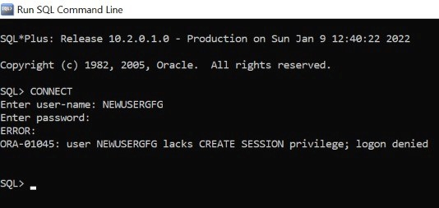

**Step 7:** Again connect using SYSTEM user-name. Now we shall enable all the privileges to NEWUSERGFG users.

**Syntax:**

GRANT ALL PRIVILEGES TO NEW_USER_NAME;

**Query:**

GRANT ALL PRIVILEGES TO NEWUSERGFG;

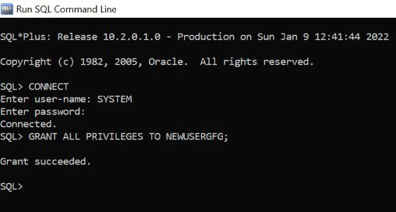

**Step 8:** We test the last step by re-attempting to connect using NEWUSERGFG user-name.

**Query:**

CONNECT

**Note:** The connection is successfully established this time and Connected is displayed.

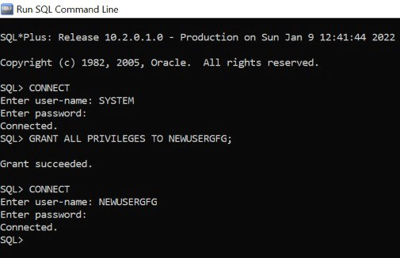

**Step 9:** Create a table named NEWSAMPLETABLE containing 2 columns i.e. ID and NAME. This further establishes a successful connection.

**Query:**

CREATE TABLE NEWSAMPLETABLE(

ID INT,

NAME VARCHAR2(10)

);

